**Flute Ensemble Performance Registration for Fall 2015 UMFA Flute Choir Showcase**

*Please submit this form by* ***October 17, 2015***  *to Marcia Metzger,* [*vp@umfaflutes.org*](mailto:vp@umfaflutes.org)*,*

*619 Oakley Circle, Hudson, WI 54016*

would like to perform at the Fall 2015

**(Name of Flute Ensemble)**

UMFA Flute Choir Showcase on Saturday, November 7, 2015 at Richfield United Methodist Church, 5835 Lyndale Ave S, Richfield, MN. Please enclose a $5 participation fee for each performer who is not currently an UMFA member; participation in Flute Choir Showcase is free for all UMFA members. Based on available performing time (at least 10 minutes, but no more than 20 minutes – specifics to be determined), our Ensemble will choose to perform selections from the following repertoire:

**Title/Composer of Selection Duration**

1)

2)

3)

4)

(This will allow us to alert you to possible duplicate programming.)

**Ensemble Director** UMFA Member: Yes No

Director’s Phone Email

Address

**Performer #1/Ensemble Contact** (if other than Director)

Phone Email UMFA Member: Yes No

Address

Performing on (circle all that apply): Piccolo C-flute Alto Bass

**Performer #2** UMFA Member: Yes No

Phone Email

Address

Performing on (circle all that apply): Piccolo C-flute Alto Bass

**Performer #3** UMFA Member: Yes No

Phone Email

Address

Performing on (circle all that apply): Piccolo C-flute Alto Bass

**Performer #4** UMFA Member: Yes No

Phone Email

Address

Performing on (circle all that apply): Piccolo C-flute Alto Bass

**Performer #5** UMFA Member: Yes No

Phone Email

Address

Performing on (circle all that apply): Piccolo C-flute Alto Bass

**Performer #6** UMFA Member: Yes No

Phone Email

Address

Performing on (circle all that apply): Piccolo C-flute Alto Bass

(List additional performing members on the reverse side, if needed)

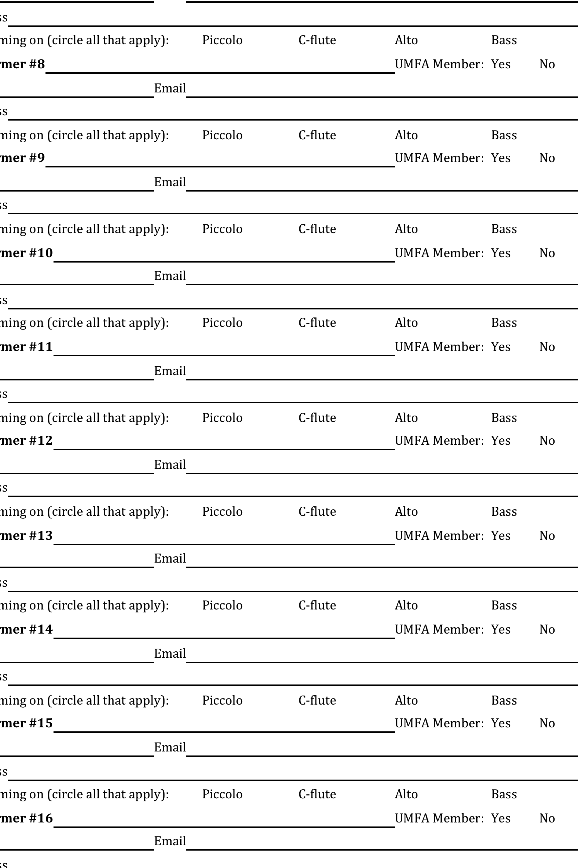





**Performer #7** UMFA Member: Yes No

Phone Email

Address

Performing on (circle all that apply): Piccolo C-flute Alto Bass

**Performer #8** UMFA Member: Yes No

Phone Email

Address

Performing on (circle all that apply): Piccolo C-flute Alto Bass

**Performer #9** UMFA Member: Yes No

Phone Email

Address

Performing on (circle all that apply): Piccolo C-flute Alto Bass

**Performer #10** UMFA Member: Yes No

Phone Email

Address

Performing on (circle all that apply): Piccolo C-flute Alto Bass

**Performer #11** UMFA Member: Yes No

Phone Email

Address

Performing on (circle all that apply): Piccolo C-flute Alto Bass

**Performer #12** UMFA Member: Yes No

Phone Email

Address

Performing on (circle all that apply): Piccolo C-flute Alto Bass

**Performer #13** UMFA Member: Yes No

Phone Email

Address

Performing on (circle all that apply): Piccolo C-flute Alto Bass

**Performer #14** UMFA Member: Yes No

Phone Email

Address

Performing on (circle all that apply): Piccolo C-flute Alto Bass

**Performer #15** UMFA Member: Yes No

Phone Email

Address

Performing on (circle all that apply): Piccolo C-flute Alto Bass

**Performer #16** UMFA Member: Yes No

Phone Email

Address

Performing on (circle all that apply): Piccolo C-flute Alto Bass